**Topic overview**

1. Participation 1

2. Specifications for the organisation of a European Cup race 2

3. Pilotes, conditions of participation, race rules (European Cup race) 4

4. Overall classification 5

5. History of changes : 6

# Participation

All FISD member countries can organise one race of the European Cup.

The European Cup can include up to 6 races per year. If the European Cup races cannot be organised by 6 different countries, individual countries may offer up to 2 European Cup races.

Only the delegates of the organising country are entitled to submit the documents with place and date for races at the FISD Annual General Meeting.

The organising country must pay an amount of €75 (deposit) per organised European Cup race to FISD at this meeting.

If the announced European Cup race is not organised, the €75.- will not be refunded.

These registration fees (deposits) will be credited to the FISD treasury.

# Specifications for the organisation of a European Cup race

* 1. Information

Information such as a map, timetable and general information must be made available to FISD for uploading to the website www.speeddown.eu at least 90 days before the date of the event.

* 1. Registration documents

The following information must be recorded. Per pilot and copilot: Surname, first name; date of birth, country of origin, licence number; category; date and signature. For minors, the signature of the legal representative must also be present. It should also be possible to submit registrations electronically.

* 1. The track

The track must have a start and finish zone and be at least 800 metres long. The average gradient must be between 6 and 12%. The maximum gradient must not exceed 20%. There is no upper limit to the length as long as the safety conditions are met.

* 1. Run-out and braking zone

Immediately after the finish, a braking zone free of obstacles and spectators of 80 - 100 metres must be created.

* 1. Approval

The promoter/organiser of the European Cup race is responsible for the course of the race, for the race track and its best possible protection. The organiser approves the course. The FISD delegates of the organising country can advise the organiser.

Artificial chicanes or corridors can be provided for very/too fast passages. 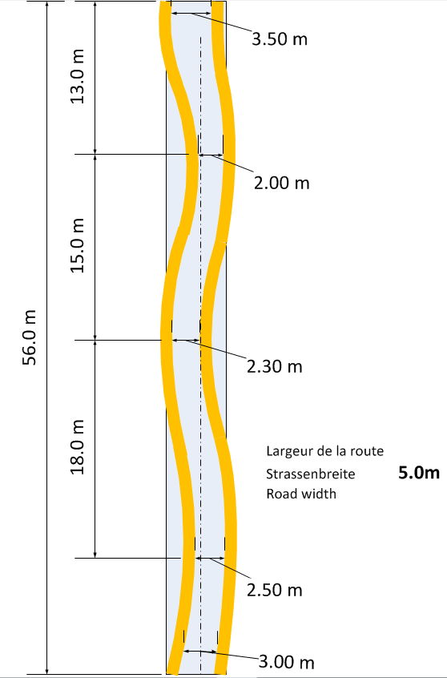

**Basis for determining a chicane**The dimensions of the illustration attached are guidelines. The illustration is intended to illustrate the following basic rules:

* In order to channel the vehicles, the narrowing should begin in a funnel shape.
* The width of the ‘gates’ should increase from ‘gate’ to ‘gate’.
* The distance between the ‘gates’ should increase from ‘gate’ to ‘gate’.
* The narrowing should be constructed in such a way that the driver cannot see through the narrowing (the centre line indicates that there is no view through the narrowing).
  1. Communication

The organiser will ensure that there are sufficient track marshals with visual contact and appropriate means of communication on the track so that the race can be interrupted immediately in the event of problems.

* 1. Track marshals

You must have a whistle to announce the drivers. You also need a red flag to stop the pilots in the event of an accident, which you must wave horizontally 50cm - 1m above the track at the drivers' line of sight. When the red flag is waved, the pilots must slow down and stop. To simplify identification, track post numbers must be affixed to the track marshals. For this purpose, A4 format boards with black on white printed numbers in a 20x20cm frame are to be provided.

* 1. Track safety

Dangerous areas in the fall line of the vehicles, such as walls, steps, sharp edges, trees and masts, must be protected with straw bales, wooden boards or other protective material anchored to the ground. Livestock fences must either be protected with nets or laid on the ground. The spectator areas must be clearly demarcated and under the supervision of the track marshals. Strategic areas such as run-off areas, fast corner exits must be provided with sufficient safety zones to ensure maximum safety for spectators.Sicherungsbretter welche unterhalb von Metallleitplanken angebracht werden, müssen eine Mindestdicke von 30 mm aufweisen.

When using ‘New Jersey’ guidance elements, make sure that they are firmly connected to each other in the danger zones. If possible, only one colour should be used on each side of the track.

In order to avoid the risk of injury to the side-car co-drivers, the barrier tape fixing posts must be positioned at least 1 metre from the edge of the track. This is insofar as the edge of the track is not covered with bales of straw.

* 1. Sound system

It is recommended, but not mandatory, to use a public sound system.

* 1. Timekeeping

A reliable computerised system must be used that enables the simultaneous management of several vehicles. The times must be determined with an accuracy of at least 1/100 of a second. All further information on this can be found in the European Championship specifications in Chapter 4 (Timekeeping).

* 1. Camping

The campsite must offer sufficient space for the number of participants. It should be laid out on a level surface accessible to vehicles and campers. The campsite must be equipped with WCs within reasonable reach. Showers and electricity connections are not mandatory.

The distance between the campsite and the track should not exceed 1000 metres. Depending on the location of the site, the organiser may be asked to pull the vehicles to the start and lead them back to the campsite after the last run.

The fee may under no circumstances exceed €35 per resident. Fees may only be charged if the campsite is equipped with toilets, showers and electricity.

* 1. The FISD race

The FISD race usually takes place over 1 or 2 days with 3 to 4 races. The scope is up to the organiser. Scoring is based on the valid European Championship rules (www.speeddown.eu). The following option is also available for European Cup races:

In the event of uncertain weather conditions, the organiser can arrange the scoring as follows:

In case of uncertain weather conditions, the organizer may arrange the scoring as follows:

* First race day - one training run (at the organiser's discretion) - 2 race runs from which the best result is recorded for the classification.
* Second race day - two race runs from which the best result is recorded for the classification.
* Final classification: sum of the best run on Saturday and the best run on Sunday. In this way, both race days remain interesting.

The time must be recorded for all runs, including the trial run. The organiser alone decides on the cancellation of one or more race runs for valid reasons (weather, dangerous track, accident). The organiser is free to organise a race for regional racers. However, these may not be included in the FISD classification.

The registration fee for a FISD event must be the same for all riders in a particular category. No difference is allowed between national and international riders.

The organiser provides start numbers which are affixed to the vehicles in accordance with the timekeeper's instructions

* 1. Pull up

This is the responsibility of the organiser. The categories C1, C2, C3, C4, C5, C6, C8, C9 will be pulled up by suitable vehicles.For safety reasons, no more than 6 vehicles may be hitched in a row.It is permitted to pull up 2 rows per towing vehicle. Pulling up takes place at an appropriate speed. The vehicles in categories C7 (Carrioli) and C10 (Skeleton) are brought to the start on a trailer or on the back of a van.

The FISD regulations regarding personal equipment also apply during the pull-up (helmet, gloves, arm and leg protective clothing, shooter, etc.).

* 1. Insurance

The organiser must take out liability insurance covering: the site, the route, the helpers, the public and the towing vehicles. Upon receipt, a copy of this insurance must be sent immediately to the FISD secretariat.

The insurance certificate must be available for inspection by FISD officials on the day of the race.

If the organiser also organises a race for unlicensed riders during the event, he must insure them against liability in the event of problems or accidents. FISD therefore recommends that the organiser also takes out special insurance for this part of the event.

# Pilotes, conditions of participation, race rules (European Cup race)

* 1. Conditions of participation

Only drivers with a valid FISD licence and a vehicle that complies with the current FISD regulations (www.speeddown.eu) may compete. The vehicle must also have a valid Certificate of conformity (*Carte Grise*).

For non-licensed riders, see sections 2n (insurance) and 2l (FISD races).

If permitted by the organiser, double starters are allowed.

* 1. Classification conditions

The FISD race is organised and scored according to the rules defined in point 2l.

If the organiser has to cancel a race run, the classification will be determined on one run. In the event of weather problems, the classification can be determined by adding the runs from Saturday or Sunday.

In order to be categorised and therefore receive attendance points, the driver must have started at least one race.

In the event of exceptional circumstances in which the race and the race heats have to be cancelled, all drivers present who have paid the entry fee will receive the attendance points and are therefore also classified. The organiser is free to decide whether to refund the registration fees to the pilots.

If a pilot has to be shown the red flag, he can repeat his run.

Pilots who are disturbed by spectators or other circumstances during their run may repeat their race run, provided this has been confirmed by a track marshal.

In the event of a complaint, this must be submitted to the FISD no later than 30 minutes after the end of the race run in question, together with a deposit of €50.

The organiser must put together a race jury consisting of the FISD delegates present at the race and a representative of the organiser.

In the event of a dispute and in extreme cases, the FISD may cancel the race.

The organiser will award a prize to at least the first three in each category (please note that in categories 5-6-7, 2 participants must be considered in each category)

The organisers must send the results of the European Cup race to the FISD secretariat within one week so that the results can be published on the website www.speeddown.eu.

# Overall classification

**5 attendance points are credited for each European Cup race contested.**

All contested races are included in the final result, whereby the worst result is cancelled in addition to the attendance points.

All drivers with a FISD licence are scored when participating in a European Cup race. They receive attendance points and placement points. For double-seaters, the co-driver must also have a FISD licence.

The overall classification is compiled by the FISD secretariat.

The allocation of points for each European Cup race is as follows:

1st place15 Points 7th place6 Points

2nd place 12 Points 8th place5 Points

3rd place 10 Points 9th place4 Points

4th place9 Points 10th place3 Points

5th place 8 Points 11th place2 Points

6th place7 Points 12th place1 Punkt

* Until the last « 0 » points
* No participation the field remains empty

The award ceremony for the European Cup will be organised by the FISD and will take place at the opening ceremony of the European Championships the following year. The licence numbers must be listed on the ranking lists of the European Cup races.

# History of changes :

Only changes requested in writing will be considered.

Edition 2007 :

* Section 4: Revision of the definition « Classification ».

***Adopted at the Extraordinary General Meeting of FISD on 19 July 2007 in Serramazzoni.***

Edition 2014

* Replacement of C.E.C.C.A.S by FISD
* Section 2, point a : Revision of the definition of « Track Marshal ».
* Section 3, point a : Revision of the conditions of participation (validity of the technical control of the vehicles).
* Section 3, point b : Definition of the race jury.
* Section 4 : 2nd revision of the definition « Classification ».

***Adopted at the FISD General Assembly on 9 November 2013 in Kdyne (CZ).***

Edition 2015

* Integration of category C10 (Skeleton)

***Adopted at the FISD General Assembly on 25 October 2014 in Oberwiesenthal (Germany).***

Edition 2016

* Section 1: Increase to 6 European Cup races per year.
* Section 1: Increase of the contribution to the FISD of the organising country from €50.- to €75.-.
* Section 2, point e: Integration of the description of course constrictions.
* Section 2, point h: Addition of the safety distance of the fixing posts.

***Adopted at the FISD General Assembly on 7 November 2015 in Stoumont (B).***

Edition 2017

* Section 2, point h: Recommendations for the protection of metal crash barriers and the use of plastic side elements.
* Section 2, point l: Start numbers provided by the organiser.

***Adopted at the FISD General Assembly on 13 November 2016 in Viu (I).***

Edition 2018

* Section 2, point h: Recommendations for the protection of metal crash barriers and the use of plastic side elements.
* Section 2, point l: Start numbers provided by the organiser.

***Adopted at the FISD General Assembly on 5 November 2017 in On (B).***

Edition 2025

* Section 2, point c: The average gradient must be between 6 and 12%. The maximum gradient must not exceed 20%. (Reason: Same rule as for the European Championships).
* Section 2, point e: The organiser approves the course. FISD delegates from the organising country can advise the organiser.
* Section 2, point l: The registration fee for a FISD event must be the same for all pilots in a particular category. No difference is allowed between national and international pilots.
* Section 3, point b: The FISD race will be organised and scored according to the rules defined in point 2l. (The organisation was described in two places in the document).
* Section 3, point b: The organiser will send the results of the European Cup race to the FISD secretariat within one week. (previously 2 working days).
* Section 4: All riders with a FISD licence will be scored when participating in a European Cup race. They will receive attendance points and ranking points.
* Change of internet address from www.fisd.li to www.speeddown.eu

**Decided at the FISD Board meeting on 2 November 2024 in Pfaffenheim (F)**