**Category C8 - Kart - 16-99 years**

**1. Definition**

A: The Category C8 admits vehicles whose chassis/frame come from motor kart racing and comply with point B below and the provisions of these regulations.

B: Copies of individual parts are not permitted. These are only parts from commercially registered companies which on the one hand are liable for their products, and on the other hand offer complete vehicles and/or their individual parts on the market for everyone..

**2. Dimensions**

|  |  |  |
| --- | --- | --- |
| **Wheelbase** | Min 1000 mm | Max 1100 mm |
| **width (front)** | Min 1000 mm | Max 1200 mm |
| **width (rear)** | Min 1100 mm | Max 1400 mm |
| **chassis clearance** | Min 20 mm | Max 80 mm |
| **rims** | 5 ‘’ | |
| **Ball bearing** | Innen-Ø min 17 mm | |
| **front tire (slick)** | 10 x 4.50-5 / 10 x 4.60-5 | |
| **rear tire (slick)** | 11 x 7.10-5 / 11 x 6.00-5 | |
| **front tire (rain)** | 10 x 4.00-5 / 10 x 4.50-5 | |
| **rear tire (rain)** | 11 x 5.00-5 / 11 x 6.00-5 / 11 x 6.50-5 | |

**3. Weight**

The maximum permissible total weight, including the driver and his complete racing equipment is defined in the general car regulations.

FISD reserves the right to grant a special authorization to exceed the maximum of 10% if the vehicle is not equipped with any ballast.

**4. Ballast**

Ballast must be secured to the chassis (at least M8).

Ballast may also be secured to the base plate using screws (at least M8) and large washers.

The use of ballast in the chassis structure is not permitted.

If the ballast weight is attached to the seat, this is to be done by means of 2 screws and washers from karting (see following illustration).



Figure 1

**5. Chassis**

The frame must be made of tubular steel. Fibre-reinforced plastic and light metals may not be used. No sharp edges or pointed ends are permitted. All individual parts of the frame must be firmly connected to each other.

All drive elements must be removed. (engine, drive pinion, etc.). The tank may be used for storage.

The use of suspension elements, suspension systems or articulated systems is not permitted.

The tubular bumpers (front and rear) must be firmly bolted to the frame (screws or quick release). The recommended dimensions correspond to the standardised specifications of the kart manufacturers, these are Ø 16mm at the front and Ø 20mm at the rear.

A one-piece magnetic steel base plate shall be bolted securely to the frames between the outer frame tubes. The base plate must not protrude beyond the outer frame tubes. The kart floor must consist of sheet metal (steel) with a minimum thickness of 1.5 mm. Welded joints are not permitted. The floor plate must completely cover at least the area between the cross tube in front of the seat and the front tube, as well as the outer frame tubes. A continuous floor plate between the front and rear tubes is permissible.

**6. Steering**

The steering must be constructed in a kart-typical manner. Consisting of a steering column, fixed and metal steering rods and must be operated with a steering wheel. All screwed steering elements must be secured with stop nuts.

**7. Bodywork**

CIK/FIA homologated front shields, spoilers and sidepods must be fitted. The CIK/FIA homologation is still valid after the expiration of the approval for speeddown races.

The outside of the side boxes must be in line with the outside of the rear wheel. The deviation must not exceed ±2 cm. This rule does not apply when rain tires are fitted.

There must be a tubular steel or plastic rear bumper attached to the frame. Plastic bumpers must be homologated by the CIK/FIA. The homologation is still valid after the expiration of the CIK/FIA approval for speeddown races.

**8. Seat**

Only seats from motor kart racing are permitted. The seat must be adjusted to the dimensions of the driver, which will keep him/her in a fixed position during the whole race run.

**9. Tires**

Only tires from motor karting are permitted. Apart from normal wear and tear, no changes may be made to the tires. The **air pressure must not exceed 3.5 bar.**

**10. Rear axle**

The rear axle, made of solid or hollow magnetic steel, can be designed in one or two pieces to allow the rear wheels to rotate independently. If the rear axle is designed in two parts, ball bearings with an inner diameter of at least Ø17mm must be used. For the bearing of the 4th ball bearing, 2 tubes with a maximum diameter of 35mm may be fitted. Joint elements which enable the alignment of the rear wheels are not permitted.

Presentation of technical solutions to make the two rear wheels independent. The mounting of the seat as well as the steering column may be placed in the middle of the vehicle. (Figure 2 and 3).

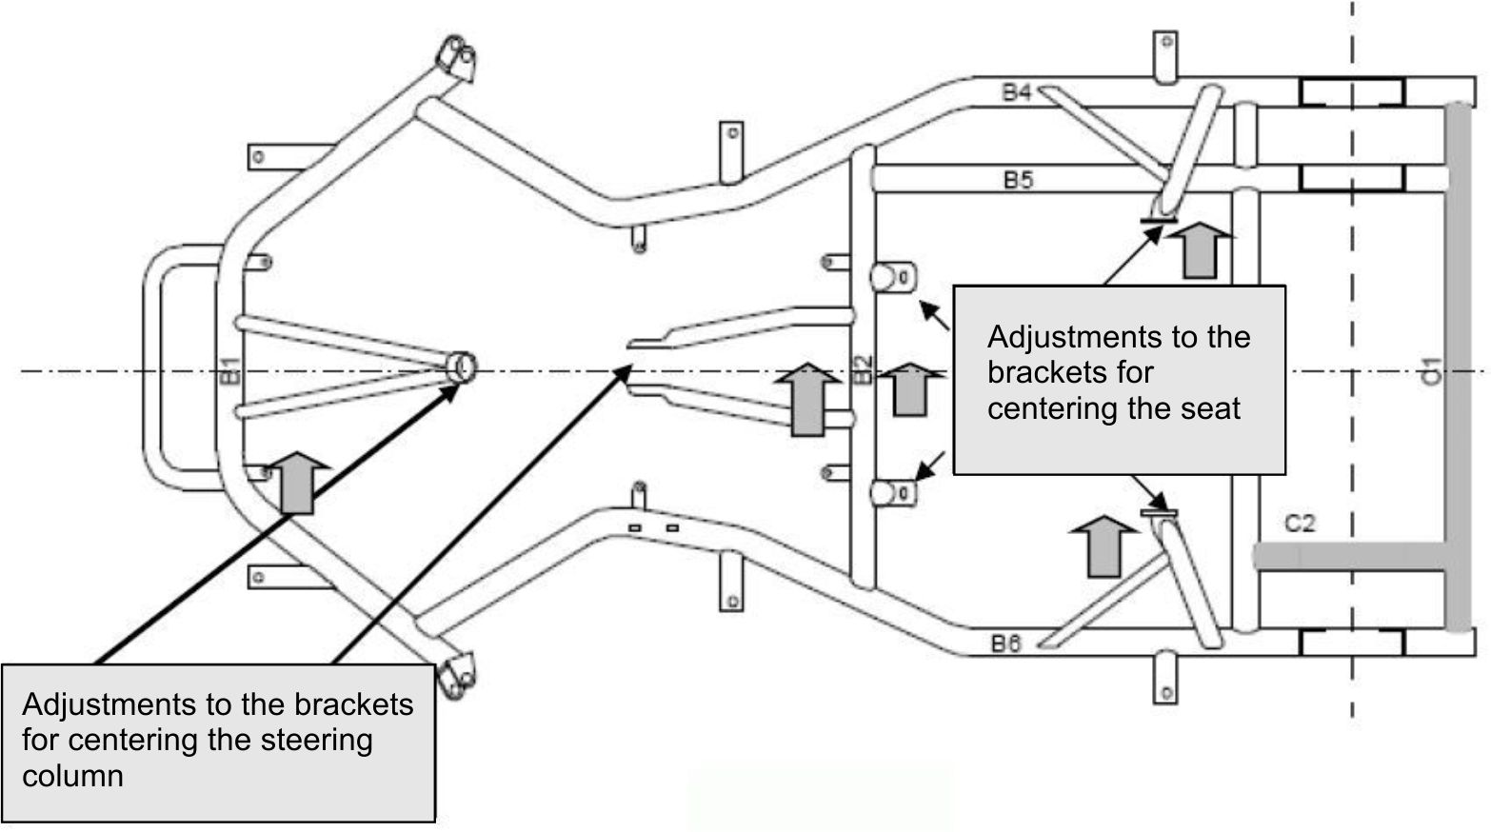

Figure 2

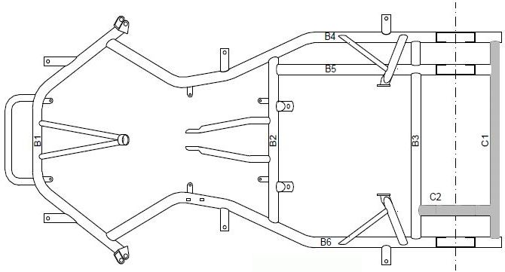

Figure 3

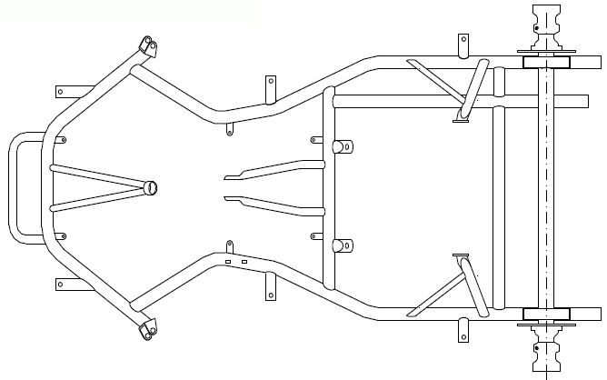

Figure 4 Chassis with one-piece rigid rear axle, wheel hubs with integrated ball bearings, without addition of tubes C1 and C2

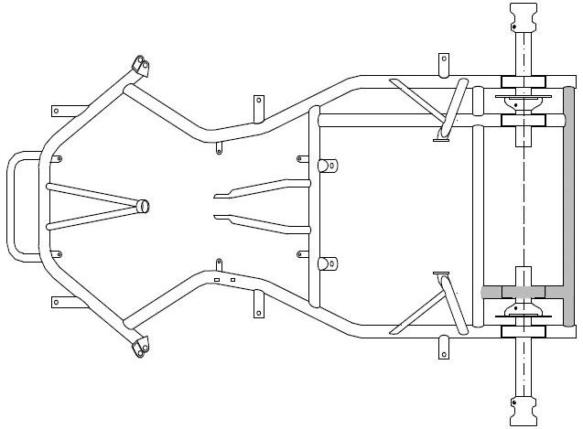

Figure 5 Chassis with two-piece rear axle, ball bearings on both shafts, with addition of tubes C1 and C2.

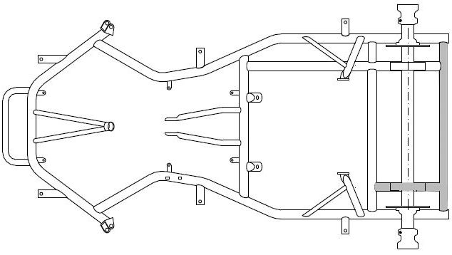

Figure 6 Chassis with addition of the two tubes C1 et C2 and one-piece rigid rear axle, ball bearings integrated in the wheel hubs.

**11. Brakes**

Only foot operated hydraulic or mechanical disc brakes are permitted. In general, brakes on one axle must act on both wheels. If only one axle is braked, then it must be the rear axle. In addition, a front brake is permitted. Power is transmitted from the brake pedal to the brake cylinder by means of a linkage, which must be additionally secured with a tensioned safety cable made of steel wire. The safety cable must not have any slack. The brake pedal must not protrude beyond the bumper even when actuated.

The pedal and seat position must be adjusted to the driver in such a way that full braking can be carried out in a normal sitting position without the corresponding leg being fully extended during full braking. The brake pedal can be extended by pedal attachments or changed in position with adapters attached to the frame.

**12. Lubrication and drive units**

Any lubrication and drive units are prohibited on the vehicle.

**13. Specific racing equipment**

The regulations according to the document " **General Regulations FISD " section II, Item B** apply. In addition, the wearing of a neck brace (as used in kart racing) and a rib protector are obligatory in this category. For the rib protector, only commercially available products from kart racing are permitted (no custom-made products).

**14. Start number**

The start number must be attached to the front plate. It must be laid out according to the document **" General Regulations FISD " section II, Item I.**

**15. Towing the vehicles**

According to the document **" General Regulations FISD " section II, Item F**.

**16. Sanctions**

Failure to comply with these regulations will result in disqualification from the race, without the possibility of obtaining special permission in the case of a FISD race.

**17. History - Changes**

First official issue and release on the occasion of the AGM in Anneyron on 12.11.2010

Adjustments and release on the occasion of the AGM in Predappio on 5 November 2011:

* Item 2: Dimension of the ball bearings
* Item 4: Alignment with the general provisions
* Item 6: Specification of the material of the steering rods
* Item 9: Removal of tyre marks
* Item 10: Definition of the rear axle
* Item 13: Redundancy - replacement by reference to the general regulations
* Item 15: Redundancy - replacement by reference to the general regulations

Adjustments and release on the occasion of the AGM of 11 November 2012 in Wittinsburg:

* Item 2: Expansion of the range of tyres that can be used
* Item 9: No more modifications may be made to the tyres.

Adjustments and release at the AGM of 7 November 2015 in Stoumont:

* Item 1: New regulation concerning the copying of parts and their origin
* Item 2: Supplement of tyre dimensions which were already defined in 2012

Adjustments and release at the AGM of 13 November 2016 in Viu:

* Item 8: Headrest
* Item 13: Introduction of a rib guard

Adjustments and release on the occasion of the AGM of 05 November 2017 in On:

* Item 4: Definition of how to attach ballast weights to the seat
* Item 13: Clarification in the definition of the chassis floor

Adjustments and release 2022:

* Item 1: Dimension rear tire (slick) 11 x 5.00-5 deleted.
* Item 5: Minimum thickness of the steel base plate 1.5 mm.
* Item 7: With slicks fitted, the side box must not protrude more than 2 cm above the rear wheel.

Amendments approved at the board meeting on November 4, 2024:

* Item 4: Clarification regarding ballast
* Item 5: Steel base plate thickness: 1.5 mm.