# FISD Technical regulation

**In case of dispute only the French version is valid.**

I. CLASSIFICATION

The ten categories are approved at the championships. (The year of birth is decisive)

|  |  |  |  |  |
| --- | --- | --- | --- | --- |
| **Cat** | **Description** | **Age Pilot/Co pilot** | **Weight** | **With/without driver** |
| C1 | Speed-car | 6 to 9 years | 140 kg | with driver |
| C2 | Speed-car | 10 to 13 years | 170 kg | with driver |
| C3 | Speed-car | 14 to 17 years | 190 kg | with driver |
| C4 | Speed-car | 18 to 99 years | 210 kg | with driver |
| C5 | Side-Car | 16 to 99 years | 110 kg | empty vehicle |
| C6 | Bob-Car | Pilot: 16 to 99 years  Co-pilot: 14 to 99 years | 330kg | with crew |
| C7 | Carrioli | 16 to 99 years | 80 kg | empty vehicle |
| C8 | Kart | 16 to 99 years | 175 kg | with driver |
| C9 | Junior Kart | 6 to 15 years | 150 kg | with driver |
| C10 | Skeleton | 6 to 99 years | 35 kg | Empty vehicle |

II. GENERAL REGULATIONS

The technical regulation is imposed in all categories:

Except for security aspects, no request will be treated before 2015.

A. Documents

An international license FISD

The car registration card for the European Championship.  
Insurance for accidents, civil liability for damage to third parties.

B. Clothing pilots and co-pilots

Body suit or two pieces including pants and long sleeved jacket, an approved helmet, and closed sturdy shoes, gloves without holes (cycling gloves and wool prohibited). Full equipment needs toprotect the entire body efficiently. A neck brace (karting type) is recommended. For specific equipment required, see block exemption regulation.

Full equipment is mandatory for all drivers during the descent and the lift up (in traction, deck truck, trailer or tray) of racing cars.

C. Ballast

Ballast weights are permitted within the maximum allowable total weight of each class. However, they must be attached by screws of a minimum M8 size to the chassis of the race car and in such a way that their loosening during the race is ruled out. If the permissible gross weight is exceeded, the driver is disqualified. The organizer must allow the driver to weigh his cart at any time during competition.

D. Energy driving

All devices capable of providing power to the race vehicle, like electric motor, springs, pedals, flywheels, cranks, etc. are prohibited in all categories. The only energy allowed is the gravitational energy. The use of dry batteries of more than 3.5V, wet cell, spray, gas, compressed air or other energy sources are strictly prohibited on all vehicles..

E. On board camera, speedometers, chronometer etc.

The on-board cameras, the battery powered speedometers (bicycle type), including racing-car models with computer data transfer are allowed. They are allowed if fixed before technical control.

F. Towing

Except for Class C7 (Carrioli) **and** **C10 (Skeleton)** attachment points securely affixed to the front and back of each race vehicle are required. Each race vehicle will have its own rope or tow strap of at least 1.5 meters long, certified over 2000 kg rupture limit and fitted with snap hooks of equal resistance at both ends. *(FISD suggests to use a strap with colour code purple. According to EN1492-2 it has a nominal holding 1000kg with a security factor of 7:1 which gives it held at break of 7000kg which is more than enough.)* The use of metal cable is prohibited.

G. Geometry of the vehicle

Adjustment systems for:

* The geometry
* The ground clearance
* The suspension

can be used before the race, when the vehicle is stationed. Systems modifying the vehicle aerodynamic behaviour during the race are allowed. The energy necessary to operate them must be purely mechanical (see point D).

H. Cooling and lubrication

Systems for lubrication or cooling of the rotating elements are prohibited during the race (eg tanks, aerosol, etc.).

I. Race Numbers

Figures should be black on a white background with a minimum height of 100mm. Numbers must be positioned according to the rules of each class.

J. Disclaimer – Car registration (Grey card)

The owner and the driver (or his legal representative) are responsible of what is built and installed on the race vehicle including the frame and wheels dimensions (the tyre pressure is under the responsibility of the driver or his parents), as well as the axles, the brakes the correct ballasts attachment etc.

A “grey card” will be formally established by FISD to identify unambiguously the legal owner and the race vehicle, this data will be monitored each year and an update will be done if necessary. (E.g. change address, owner and / or the racing vehicle.) The purpose of this “grey card” stems from the imperative need in case of accident it is legally required to identify the owner of the concerned vehicle. The toll grey card is issued for a period of 6 years (validity from the date of issuance) with an annual review; FISD alone is authorized to issue grey cards.

K. Technical Inspection

Technical inspection (including weighing) can be made at any time of the competition, even after the end but before the results validation. This is especially true for possible changes to the racing vehicles during the competition and after the first technical inspection.

Vehicle weight should remain the same throughout the duration of the race. The pilot (and the co-pilot in categories C5 to C7) remains at disposal of the technical commissioner for eventual technical inspection or weighing. All decisions of the commissioners will be submitted to FISD committee and will be final and binding.

For technical checks each pilot and co-pilot, must submit their equipment (helmet, gloves, mandatory pads and clothing).

III. Building regulations and safety

A. For all categories

1. Frame work

The frame must be constructed using only solid materials which guarantee the consistency of diameters and technical parameters provided by Regulation. All joints shall be made by solid welds, screws, rivets or adhesives of sufficient strength. The construction of the chassis is left to the manufacturer’s freedom. The nuts should be secured with pins, castle-nuts, nylon shaft collars (Nyloc nut) or glues and pastes.

**Definition of the chassis**

Rigid frame made of wood or metal that holds or carries the wheel, suspension, braking and steering systems and body of the cart. Monohull construction is permitted.

2. Floor

The floor may consist of several parts. It must protect the entire length of the crew’s bodies and must be assembled to the chassis. The interposition of rubber or plastic with a maximum thickness of 2 mm is allowed.

3. Body

If a body is permitted in the category, it must be of a solid construction. Building materials are open, as is the shape of the bodywork.

The body may be in one or more pieces, but easily removable in case of inspection. For the crew’s safety, there must be no rough or sharp edges inside or outside. Provide for minimum radii of 5mm.

The bodywork must be securely attached to the chassis without the possibility of loosening during the race.

In the categories C1 to C4 a body with a minimum height of 200mm from the bottom edge of the chassis must cover the front and sides of the race vehicle.

If the body is closed, the opening part must be fixed securely to the main body or to the chassis and its opening must be possible from inside and outside the vehicle.

For a better accessibility to the start ramp, a minimum angle of 10 degrees is recommended.

In case of insufficient rigidity of the front part of the body a roll cage reinforcement is required.

The pilot's legs must be protected by a roll cage in case or an overturn (see Figure 11). The construction of the body shall be absolutely safe for the pilot.

4. Windshield

The windshield must be made of a non-breakable material. If it is less than 4 mm thick, its edge must be protected by a plastic or rubber beading. If it is more than 4 mm thick, it is sufficient to round the edge - see Figure 1.

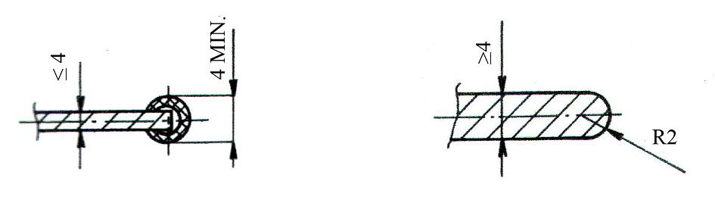

**Figure 1**

5. Axles

Except for Class C7 (Carrioli) axles must be made of steel, and secured to the chassis so that bending is minimised. By this we understand even the possibility of mounting the axles to the chassis using a sleeve with bearings in which it can rotate freely.

6. Steering

The steering system may have only a minimal play. For all categories except that of C7 (Carrioli) steering can be performed on all wheels.

7. Brakes

In C1, C2, C3, C4 and C6 a dual circuit system must operate on all four wheels, regardless of the schematic - see Figure 2.

Circuit 1 Circuit 2

Circuit 1 Circuit 2

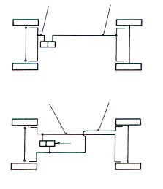 

**Figure 2**

Warning:

For vehicle in C1, C2, C3, C4, C6, C8 follow role has to be respected: As soon as the brake system is actuated by any type of traction, a safety cable is required. (see Figure 4).

Two metal rods

**No single pulling rod**

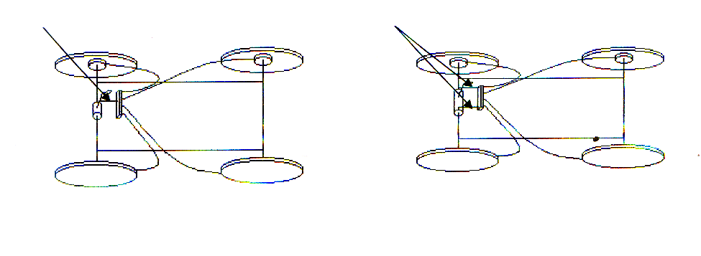

**Figure 3** **Figure 4**

**Example of a solution to figure 4**

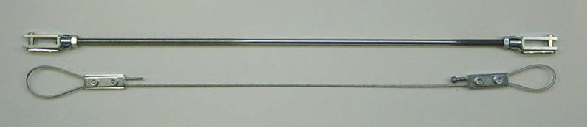

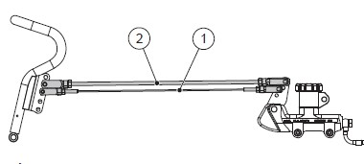

8. Harness

The harness is mandatory for all categories C1 to C4, (C6: from 2018 mandatory for new vehicles, from 2020 mandatory for all vehicles) 3-point system minimum, rally type. Belt retractors, even blocked are prohibited. The harness must be worn tight throughout the race (descent and ascent). The harness protection of the driver must pass over the hoop or over the seat if the latter is strong enough - see Figure 5.

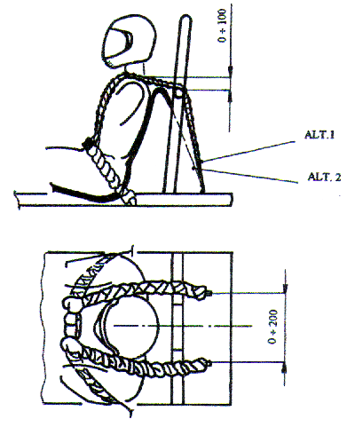

**Figure 5**

9. ROPS Roll Over Protection System

The ROPS is compulsory for classes C1 to C4 **and C6**. ~~In class C6 the ROPS are at the moment only advised. (C6: from 2018 mandatory for new vehicles, from 2020 mandatory for all vehicles)~~ The tube used must be of minimum diameter 25 mm, minimum thickness 2mm. The definitions of ROPS are specifically described in the regulation of the classes C1-C4 and C6.

**General regulation for the ROPS**

Enhancement (a max extension) of the bow is allowed, provided it is welded to the hoop and the existing parameters of the bow (Ø25mm tube thickness 2mm) are met and that internal measures are within than 200 mm high and 100 mm wide - see Figure 7. Respecting the rule of 65% mini with side supports.

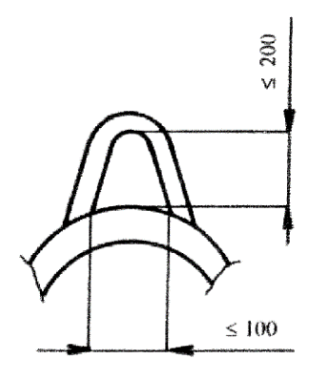

Figure 6

The rod connecting the support hoop must be welded or bolted to it, without drilling - see Figure 7.

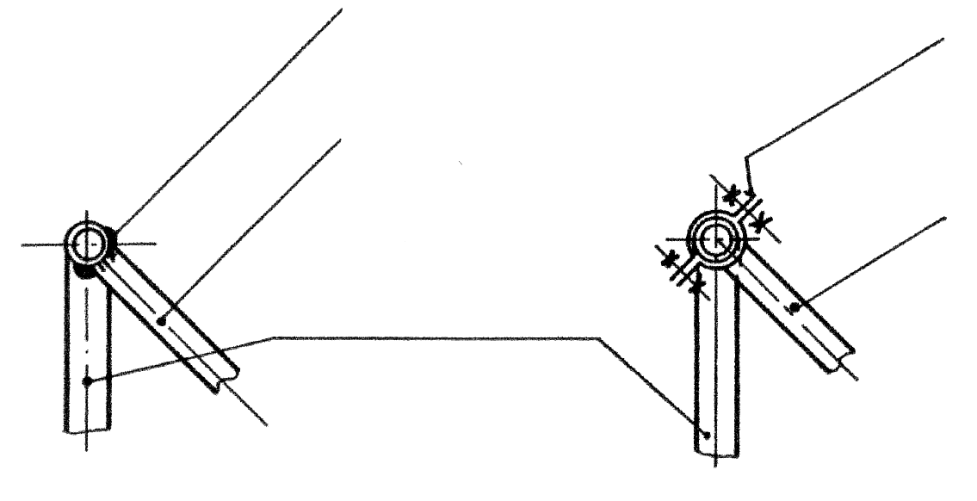**Figure 7**

Welded

Rein of tightening

Counter attached

Counter attached

Rollbar

The attachment of the arch on the frame should not decrease the resistance of the protection. Consequently, the type of attachment as described below must not be used - see Figure 8.

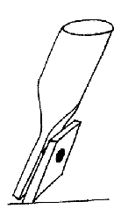

Figure 8

Recommended attachment of the arch to the frame - see Figure 9 below.

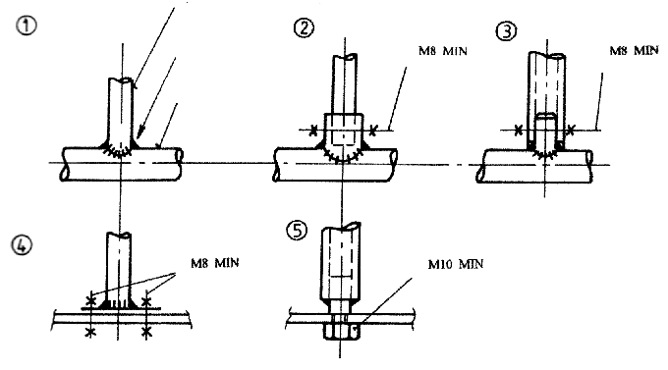

Figure 9

Rollbar

Welded

Frame

If the vehicle consists of a self-supporting (monohull), the roll bar should be attached at the lower part of the racing car.

**Lengthening techniques of tubes:**

- Set enough current to ensure a solid weld, not only "gluing"!

- If the welding is made correctly, a sleeve is not necessary.

- Internal tube:

🡪 To ensure proper welding, it is important to let min 5 mm space between the two tubes to be connected.

- To increase the strength of the connection, we can drill semi crossing holes (Ø 6-8mm), near the ends of the extension tube (sleeve) and weld afterwards the holes.

External tube Internal tube

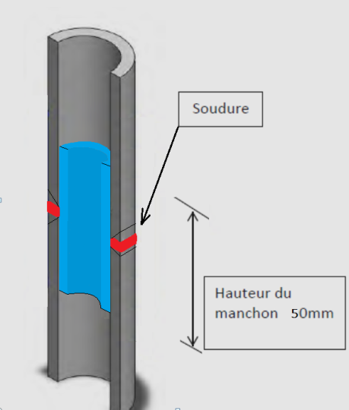

10. Tyre pressure

The maximum tyre pressures are limited to:

* C1 to C6: 4.9 Bar
* C8: 3.5 Bar
* C9: 3.0 Bar

No tolerance will be permitted.

If the measured pressure of a racing vehicle exceeds these values, the driver will be immediately disqualified from that race.

Each driver not complying with the standard pressures indicated above or with those indicated on the tyre (possibly less that 4.9 bars), will assume full responsibility in case of an accident. (See Section J responsibility)

Checking tyre pressure: For C1 to C6 and C8/C9, the inflation valve must be accessible at all times, both front and rear. If this is not the case it is the task of the pilot to make the valve in question accessible.

Pressure gauges will be provided by the race organiser for consistency.

11. Track

All marks or signs to assist trajectories and / or braking are not allowed on the track. (Roads, pads, etc.)

12. Penalties

The non-compliance with these regulations shall result in exclusion from the competition without any exception in the case of a race FISD.

13. Modifications history

Modifications approved at the GA in Oberwiesenthal on 25.10.2014:

* Item II F: Towing – load capacity changed to 2000KG
* Item III AI. 10: Definition of who is responsible for the valves accessibility.

Modifications approved at the GA in Stoumont on 7.11.2015:

* Item I : New weight limits for C1-C4 and C6 (with belts and ROPS)
* Item II J : Clear definition of the purpose of the registration document
* Item III A.7 : Clear definition of the security cable for by traction actuated brakes
* Item III A.8 : Proposal to apply seatbelts for category C6
* Item III A. 9 : Proposal to apply ROPS for the C6 category. The description of ROPS   
   and their variants are represented in the specific regulations of the  
   different categories

Modifications approved at the GA in Viu on 13.11.2016:

* Item 8 +9 : Enforcement of roll bars and seat belts in C6

Modifications approved at the GA in On 05.11.2017

* Item I : Category C10 becomes the status of official category in FISD

Modifications approved at the GA in Paffenheim 04.11.2018

* Item I : New weight limit for C3
* Item I : New age limit for Co-pilot in C6

Modification GA Sant Andrea 06/11/2022 :

* Weight C5 + 10kg

Modification GA Bellevaux 04/11/2023 :

* Point I : Weight C2-C3 + 10kg
* Point I: Total Weight C9 = 150kg and ballast is authorised
* Point I F : added C10
* Point II A 9 : added C6
* Point II A 10 : added pressure for C9